PostMapping(“/authenticate”)

reuestBody
{
Username:alice,
Password:alice123
}

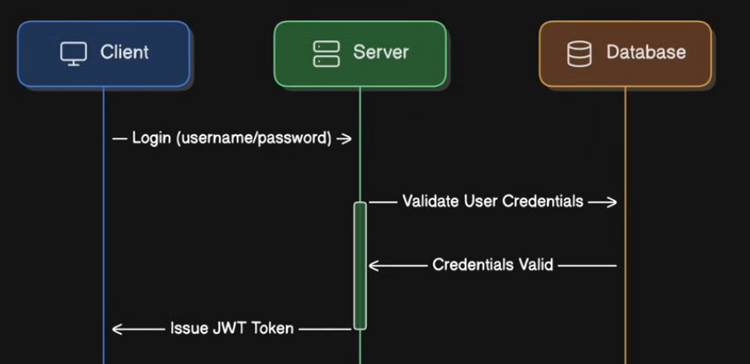

DeleteMapping(“/delete-product”)

Header
Authorisation : Bearer yasicyad7a8d6a7d6a7d5a7sd5

